Saint

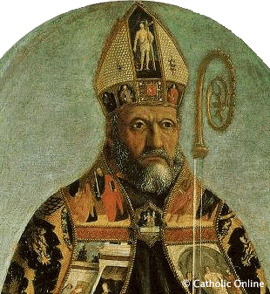
By
A prayer to my saint:

About my Name Saint:
Why my Name Saint has inspired me:

